Experiment 3 OpenCV
3. Perform basic Image Handling and processing operations on the image
• Read an image in python and Convert an Image to show outline using Canny function.
Program:
import cv2
image = cv2.imread("nature.jpg")
gray = cv2.cvtColor(image, cv2.COLOR_BGR2GRAY)
edges = cv2.Canny(gray, 100, 200)
cv2.imshow("Original", image)
cv2.imshow("Edges", edges)
cv2.waitKey(0)
cv2.destroyAllWindows()

Input:
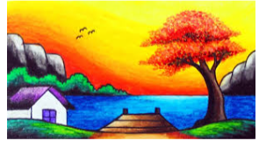

Output:
